Background Questions

What is the purpose of the website? MinecraftEdu needs a website to showcase their Minecraft software for schools.

Who are your target audience / end-users? For students in schools raging from all age.

Design Concepts (Briefly explain why)

**DRAFT 1**

***Colour Scheme: (Insert colour scheme options below)***

Black- This color is very clear and doesn't affect people with eye color problems. With a background looking black, it makes the items and text on that background page to stand out. I will use this color for the navigation bar and footer

White- This color represents cleanliness and organization.. White space around an item or text makes our eyes draw to it associating it with importance. White is the opposite of black. WIth white space after the background image, it makes the pictures and text stand out.

Yellow- I will use yellow color, for the highlights of my tabs or to show to the audience that they are hyperlinks. I have a dark background for my nav so when I use yellow as high for the tabs, when your mouse is hovering over it, the color is sharp and will stand out(because it is in a dark environment) to their eyes.

***Font/s: (List font choices)***

I will use **san- serif** text rather than **serif** because Sans, according to research, is more readable than the other, hence it is used mostly in every website you see. Serif, are good for printed out works and stand which portrays more seriousness. Hence you see it more in work documents and headers

Alef - Lorem ipsum dolor sit amet

**Draft Layouts: (Insert layout options below)**

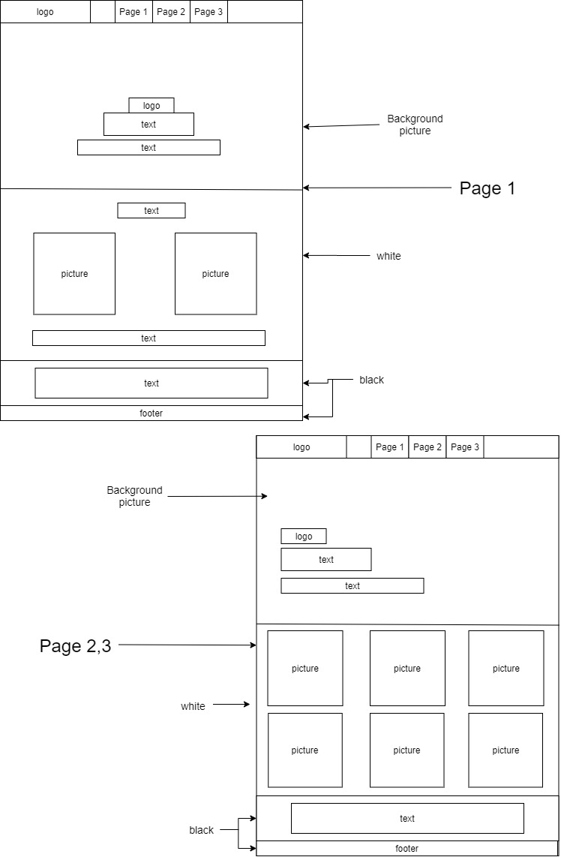

**DRAFT 2**

***Colour Scheme: (Insert colour scheme options below)***

Gold - It is associated with love, compassion and wisdom. This website is to help the education of students, so to make it more attractive and interesting to read about, I will use this color to communicate in that attractive and interesting way to them. I will use this color for the navigation bar and also for the footer. This gives the website a more vibrant and happy feel.

Black - The color of the text in the content will be black. This is because it will be on a grey color background. The text on the Navigation bar will be black, as the background is yellow and will go well with black because it will make it stand out.

Hex - It is a shade between the colors black and white. It is used mostly by most gaming sites for their contents. So I choose it as a color to use for my content background. It neutralises the color yellow so it is not too much colors and it acts

White - The color of the text in the background image, will be white as it will be on a background that is darker. Also for the contents which are under the background image, where the text and images will go, it will be white. THis all is for readability purposes.

Yellow - This is for the navigation bar. As you hover your mouse on the tabs, for the user to see if the tabs are working and to show him what he is about to press, it will highlight in yellow. The Gold is a bit dull but to see what's hidden behind the hyperlink, it gives the mysterious happy feel.

***Font/s: (List font choices)***

Francois One - (Lorem ipsum dolor sit amet)

It has a modern feel and stylish effect on the tip of its letters. I believe a text like that is more suitable for young people of today.

**Draft Layouts: (Insert layout options below)**

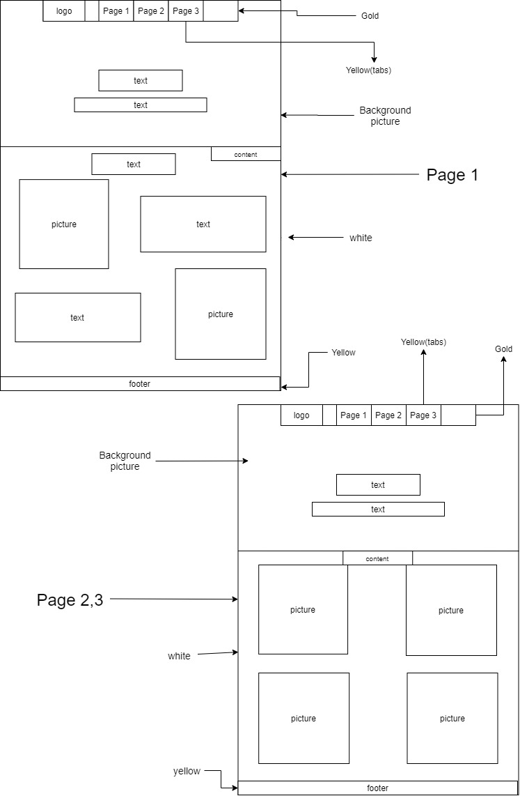

**DRAFT 3**

***Colour Scheme: (Insert colour scheme options below)***

Green- I will blue for the color for the 3-lined shape next to the Logo. That will be a sidebar menu which will pull by when you press on it. You realise this Main page doesn’t have a normal navigation bar as most websites do. Plus it will be located above a background image. So to make this sidebar menu icon stand out for the end-users, I choose green as it is bright enough to stand out. It is a color that is associated with growth, environment harmony, etc. This is what Minecraft is about, it is about building something in your world(growth/environment). The sidebar when it pops front, when you press the navigation bar, plus the footer color are all going to be green.

Beige - This color will be the color for the content area. It is a shade of yellow but not completing yellow. It is associated with a sandy, calm, neutral and relaxing effect. This won’t hurt the readers' eyes when reading. It doesn’t blend in with Green color but with its dullness, you can easily pick out where the Navigation Icon is.

Black - Text will be black for readability purposes. The content is full of pictures and less text. With the background color, beige, it gives them a nice calm feeling as they scroll through the content

White - On the Navigation menu, the fonts on these will be white as it will stand out more in the green background.

***Font/s: (List font choices)***

***Iceberg -*** This font-type has a “boxy style”. As Minecraft is more of building things out of blocks/ in a square/ rectangle shape. With this type of 3D game, and its feel, I chose this font to go with it

***Draft Layouts: (Insert layout options below)***

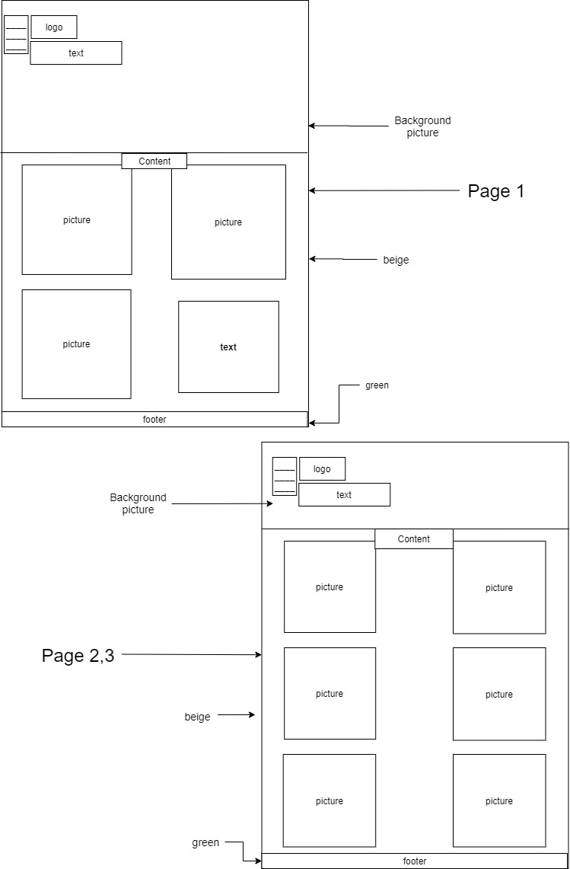

**Final Design**

***Feedback or Survey:***

|  |  |
| --- | --- |
| 1st Brother**(Gideon)** | 2nd Brother**(Richmond)** |
| He said he loved the second Draft. His reasons are because the use of the spaces in the design, especially the intro page is really nice and attractive. Every space adds to the feel of the website. The content area of the intro page, has really nice artistic feel; as it goes from “Picture to text” , and then “text to Picture”  The spaces in “Page 2, 3” of Draft 2 are little but are all confined nicely and organised in that amount of space.  Another reason he chose this was because the style of Draft 1’s “Page 2 and 3”, has a large space on the side of it above the content page. But Draft 1’s “Page 2,3” follows the same style of the intro which makes it outstanding.  He didn’t bother about Draft 3 because it was unattractive to him because of how it was arranged. | He said he loved all the designs but his favourite one from all is the Draft 1.  His reasons are, for the Intro page, it is really organised and you can easily find what you are looking for. From the text in the middle to the background image goes down to the content which has a text, center aligned on top before 2 pictures on each side. A text and a text, followed by a footer. They are evenly spaced out and follow a certain hierarchy feel.  He also preferred the “Page 2, 3” of Draft1 because when you look at the background picture, all text is grouped at the left corner and there is a large space. He said that that space can be filled with a picture. Its style has a different feel to its intro page. |

***Final Colour Scheme: (Insert colour scheme options below)***

Green- I choose green as it is a color that is associated with growth, environment harmony, etc. This is what Minecraft is about, it is about building something in your world(growth/environment). The navigation bar, plus the footer color are all going to be green.

Gold - It is associated with love, compassion and wisdom. This website is to help the education of students, so to make it more attractive and interesting to read about, I will use this color to communicate in that attractive and interesting way to them. I will use this color for the navigation bar and also for the footer. This gives the website a more vibrant and happy feel.

Yellow - This is for the navigation bar. As you hover your mouse on the tabs, for the user to see if the tabs are working and to show him what he is about to press, it will highlight in yellow. The Gold is a bit dull but to see what's hidden behind the hyperlink, it gives the mysterious happy feel.

White- This color represents cleanliness and organization.. White space around an item or text makes our eyes draw to it associating it with importance. White is the opposite of black. WIth white space after the background image, it makes the pictures and text stand out.

Black - Text will be black for readability purposes. The content is full of pictures and less text. With the background color, white, it gives them a nice feel to the eyes as they scroll through the content.

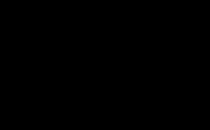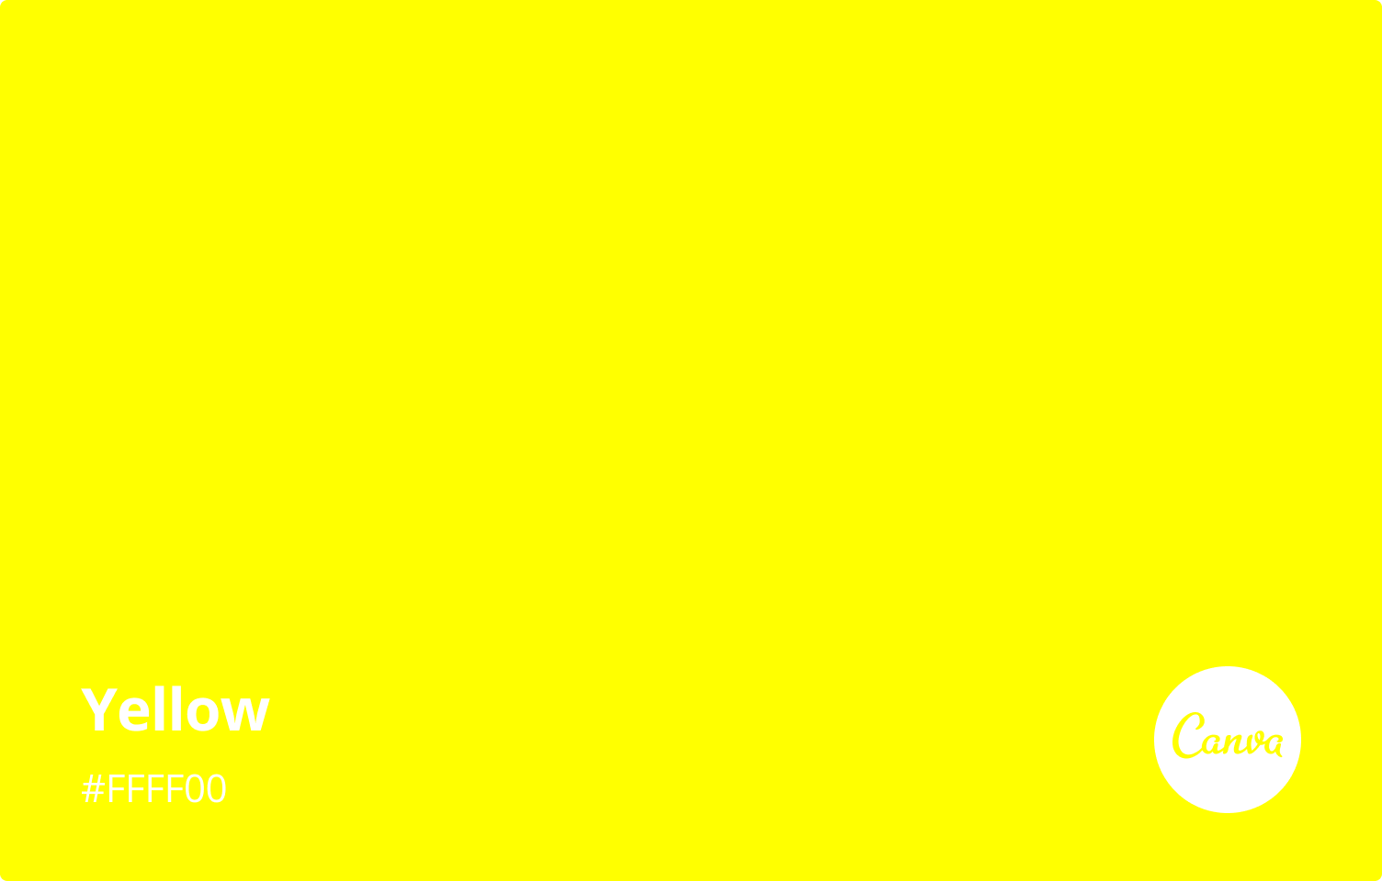

***Final Font/s: (List font choices)***

Francois One - (Lorem ipsum dolor sit amet)

It has a modern feel and stylish effect on the tip of its letters. I believe a text like that is more suitable for young people of today.

***Final Layout: (Insert final layout below, include final colour scheme, fonts to be used and proper labels e.g. heading, images, etc)***

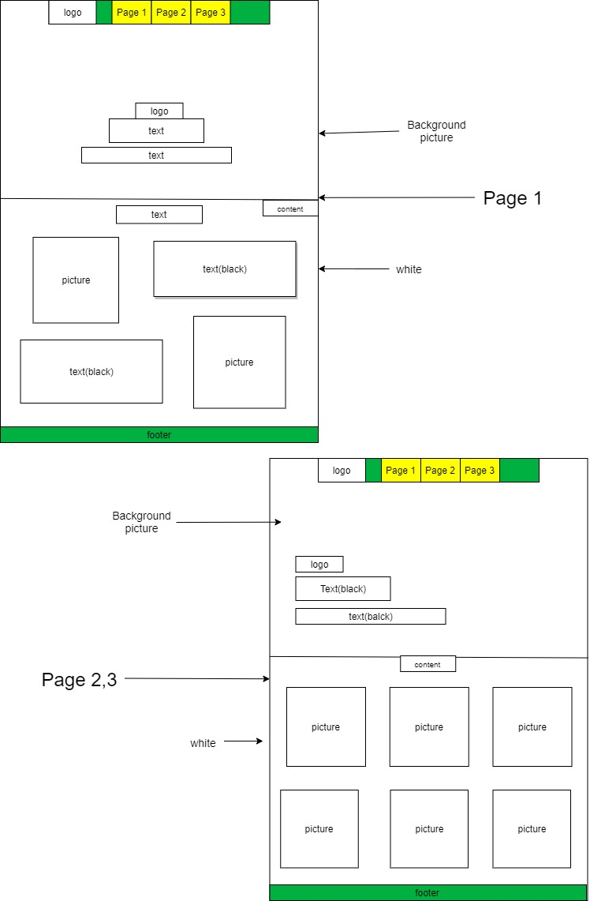

**Design Ideas Used:**

***Design Ideas (at least 2) Describe the design idea. How is it used in your website? Explain the appropriateness to the purpose and end-users.***

Color- Without color in a design the design becomes empty and unattractive to read. With color in a design, it links up with what it is being talked about mostly and makes the website more engaging to its users. On my website the colors I am using are Gold, Yellow, Black and White.

* Green - I used this color on my navigation bar and my footer. This color is associated with growth and thought growth and building stuff(Minecraft) goes together well. That is why I used it. Plus it is a good color to make yellow stand out
* Yellow - I used it for the color of the tabs when a cursor hovers over it. The color green will make it stand out because it is a dull color carrying a bright color.
* Black - The color of my text will be black because the background where most of the writing will go will be black.
* White - In the content area where there are only pictures, I have used white space as it creates an importance, and organized feel for the items in it.

I can say that color in an overall, will communicate well with my end-users who are going to be students. We are building a website that is going to help young people learn. So it is best to choose a color that attracts them and resembles what they are learning about, than choosing a color that doesn’t match the color of the game they are planning and not attractive.

Cosmetic- It means affecting the appearance of something rather than its substance. When I look at my draft and the colors added to it, how the pictures are going to be arranged with the text, they look really appealing and attractive. For e.g: The Page 1 of my draft, when you look at the content area, it goes like this, “Picture and Text” and “Text and Picture”. This is usually but it is nice and it gives it an artistic feel. Something appealing to watch

I can say that my end-users will like it as, firstly it is usually and young people are used to websites being centered mostly. So used that style to make it more of an Asymmetrical style. This will help the student to be engaged as they read it because it is cool and appealing to watch.

**Design Principles Used:**

***Design Principle (at least 3) Describe the principle. How is it used in your website? Explain the appropriateness to the purpose and end-users***

1. Balance(Asymmetrical/Symmetrical) - To have the opposite side of an element/ half of a design not quite in equal proportion. An example of that can be a tree or. The opposite of Asymmetrical is Symmetrical where each side of a design when cut in the middle are still in proportion to the other.

When you look at my design, the navigation bar doesn’t have an equal ratio due to how I have arranged the tabs. I got the Logo all the way to the left corner and then the 3 tabs are situated in the middle, leaving the right corner blank. The content area also follows the same style as, I got Picture followed by a text to the side. But when you go down it, it is the other way around, Text and Picture. Page 2, 3, when you look at the background image, you can see that the text is all grouped to the right side. These are all Asymmetrical styles.

When you look at my design again, the intro page, where the background image is located, you can see that the text is centered in the middle. When you look at the “Page 2,3” you can see that it follows the same pattern for its content area. They are even on both sides if I cut it into. These are all Symmetrical styles.

I played around with the balancing of things in my website to give it a visual interest to my end-users and not just the same old boring stuff where things are centered in the middle for every page. Students are interested in new things

1. Repetition - To stick to one style and use it in your composition repeatedly. For example if you limit yourself to three strong colors in your design, it is okay. It is said that repetition unifies and strengthens a design.

When you look at my design, there are certain things I am maintaining in all 3 of my designs:

1. Color - Green color for my navigation bar and footer. Yellow for all my tabs when a cursor hovers over it. Black for my text on white background( or vice versa if needed). The content area is always white color.
2. Text type- I am using just using Francois for everything( for e.g, for my text in the middle or side of the background image)
3. Equal picture shape- The same size of pictures when put on the content page; will increase or decrease if needed

I believe that if I use too many colors, it is attractive, it makes it too sharp for the eye to contain. No need to change the text, sticking with the same is better all I have to do is increase or decrease. Same goes with pictures. Repetition will help the eyes of my end-users to navigate well through the website which will help them to find what they are looking for.

1. Proximity - When you group similar elements together in one place, you design can be said to have proportion. This means your audience will approach your work in sections instead of a whole

When you take a look at my design, it has been grouped well enough. The navigation bar contains the logo, Page 1, Page 2 and Page 3. This is all needed for my navigation bar. When you go down. You see the logo again. Then a short text talking about what you will be seeing in my text. When you go down again, you can see that the content page contains what is needed. WIth the footer, it will be containing my name to the right side. That is it

I can say that this principle of design really helps me to meet the goal of helping the kids find what they are looking for by grouping them in sections as a whole. It will make my website a useful tool for their education because it is easy to find what you are looking for.

Implications

Relevant Implications (at least 3) Describe the implication. Address the implication in the design and website. (You may include screenshots)

1. Social - When you see the word social it talks more about people, interacting and more like a group of people. The social state of this website is targeted at students at school. The company wants to make a website that will help these kids learn about Minecraft. So to address this problem, I will use a color that is related to the game which will get young people to be engaged in what they are doing. First of all I choose to do Gold and yellow for my website because these two colors are associated with love, passion, etc. But that is not really connected to what the website is about.

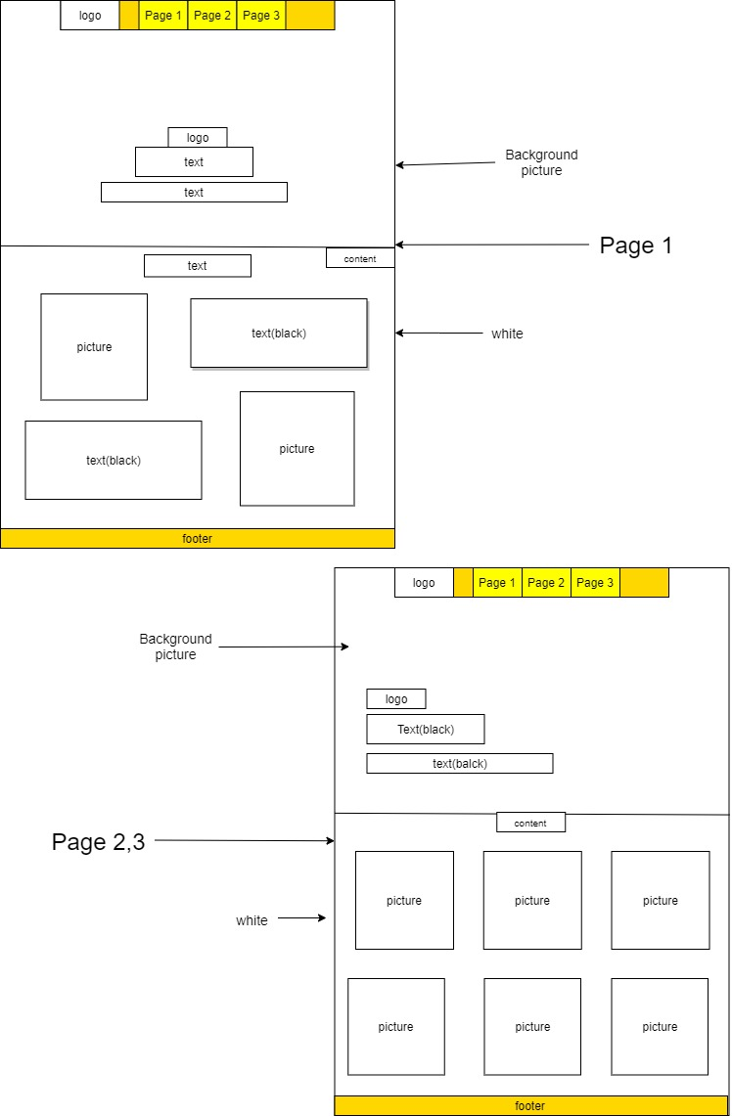Before After

So I choose green and yellow because green is for growth connected to building stuff(minecraft) and yellow to engage them in love with the course(attractive).

1. Sustainability and future proofing- For sustainability, I will want my website to load really quick. To solve this issue, I will use smaller pictures and if I need to use any big pictures will have to scale it down using Photoshop. This will reduce the long wait and reduce server space being full.

For future proofing, I will want my website to be responsive. As to when it is viewed with Ipad and phone, it resizes to fit the screen of the device appropriately. To do this I will include this code in my meta which will help me to achieve that goal.

Also I will add comments in my css so you know what you are looking at; what codes for what.

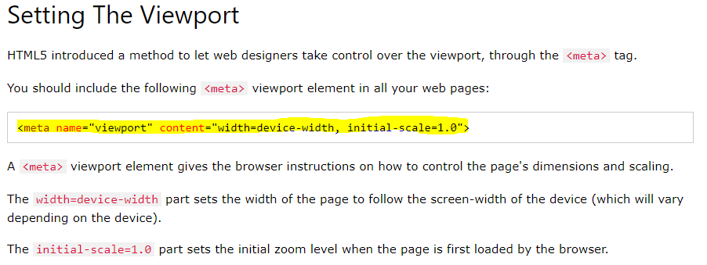

***I will put pictures on how I used these when I made the website.***

1. Functionality - This is more dealing with why the website was created in the first place; does it achieve its purpose. This website was made for MinecraftEdu to showcase off their software. To meet this requirement, I will have information that is related to that.

I will also validate my work to make sure all my links are working.

Work Log (Data Integrity and Testing)

· This is updated every time you work on this assessment.

· Enter briefly what you have done for the day, screenshots if necessary.

· Have you check for data integrity? Provide evidence, if necessary.

· Have you done any test and was successful / found errors then successfully corrected? Provide before and after evidence(s).

· Have you made changes to your design? Briefly explain why and is it still appropriate to the purpose and end-users.

Day 1

Day 2: 2/04/2020

I did my 3 drafts explaining their color schemes, fonts and showing a picture. I found some difficulties doing the drafts(Are you allowed to do the same color and font scheme to all 3 drafts?) so I texted the teacher and he helped me to understand it.

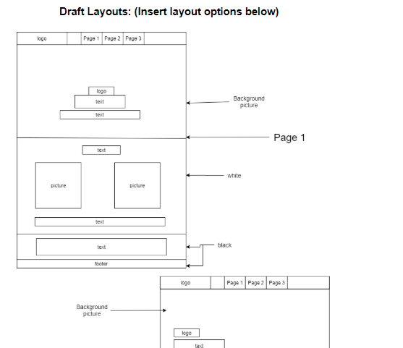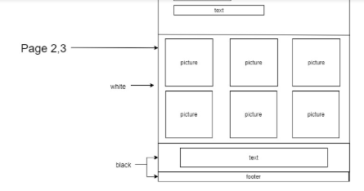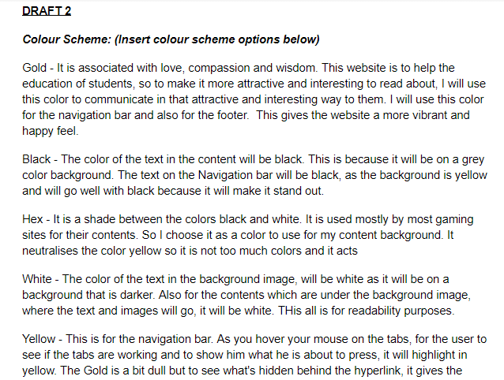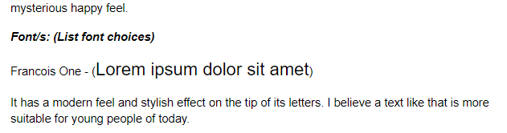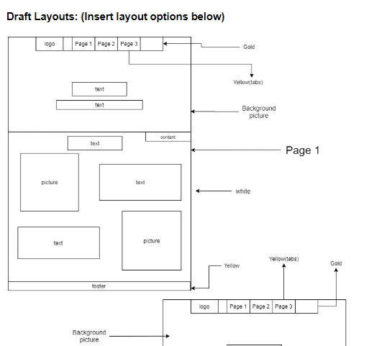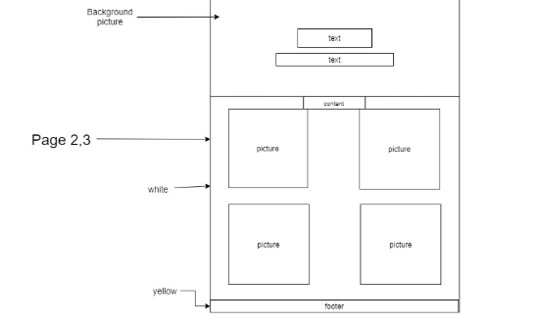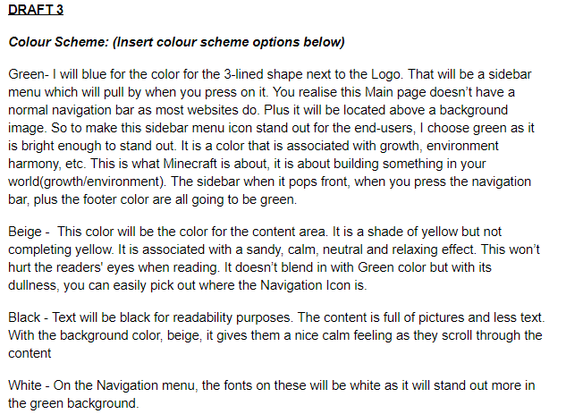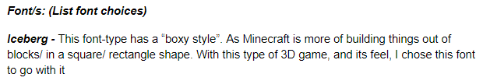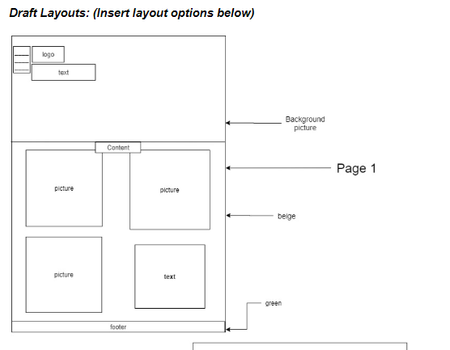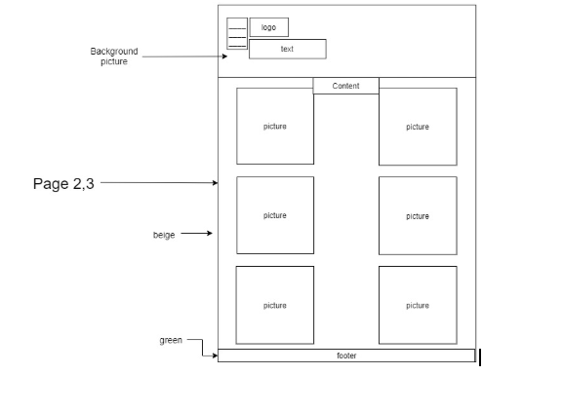

Day 3 (3/04/2020)

I tried my best to finish everything in task 3 which is the “Design layout and Plan”. I have to just do 3 Principles of Designs under that task and move on to the Implications, then Website Creation.

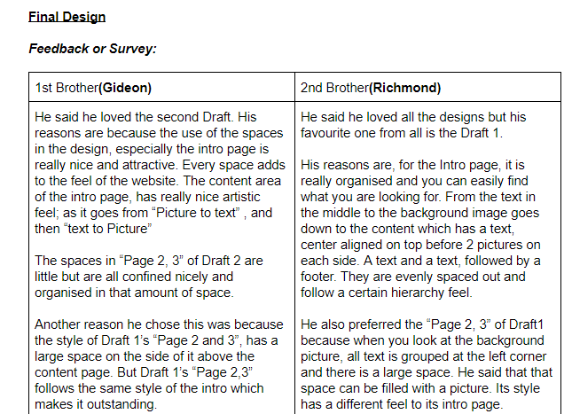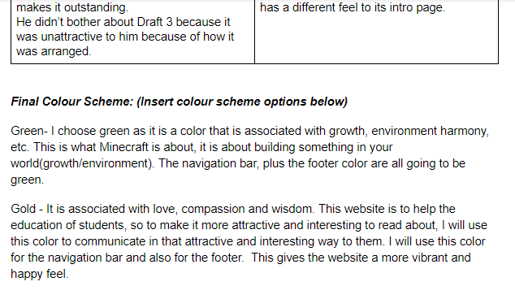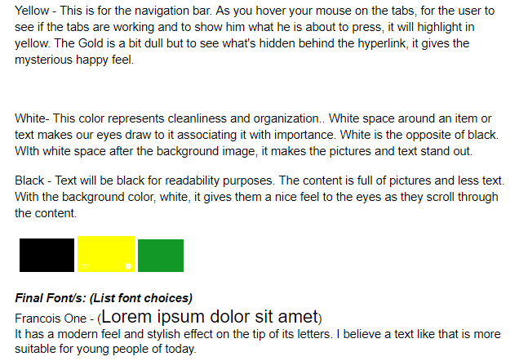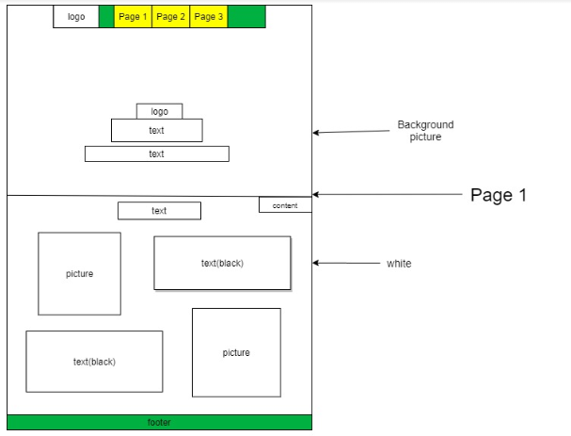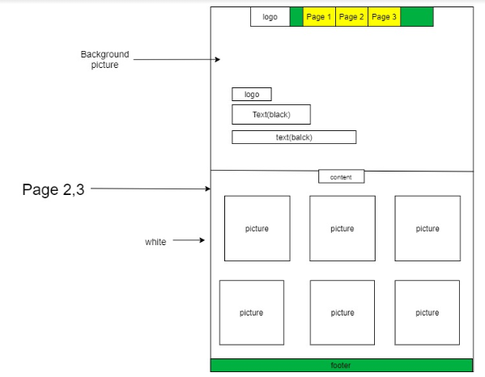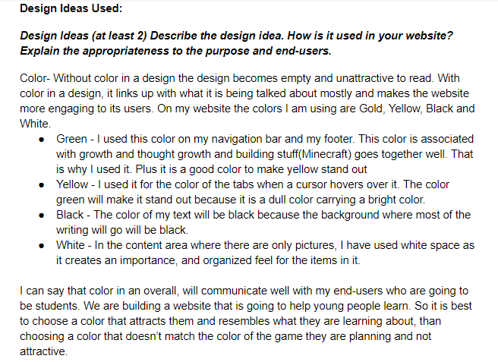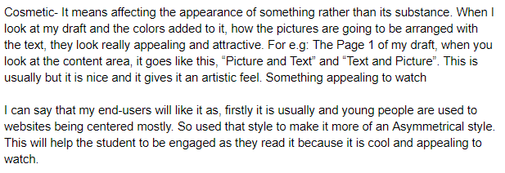

Day 4(4/04/2020)

I am yet to create my website as I have finished all my planning work. I just need some pictures to prove for my 3 chosen “Implications”.

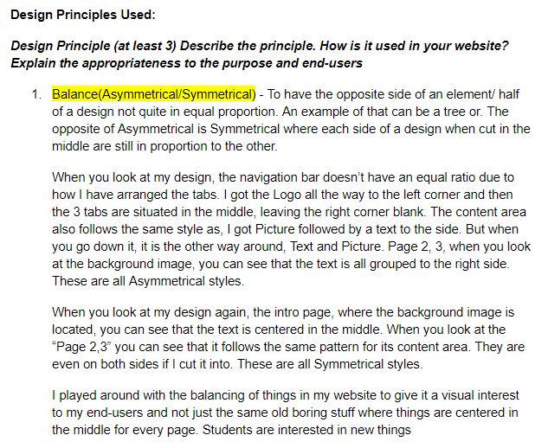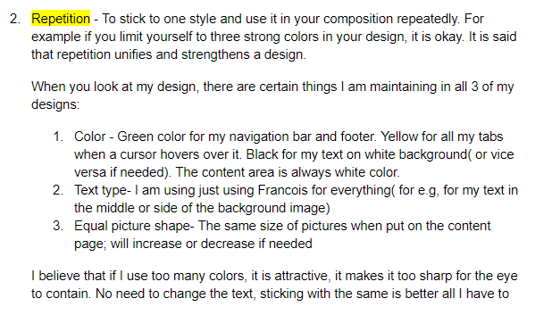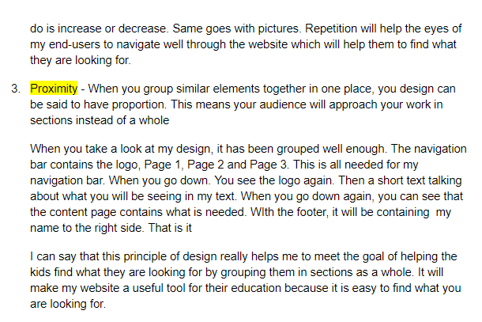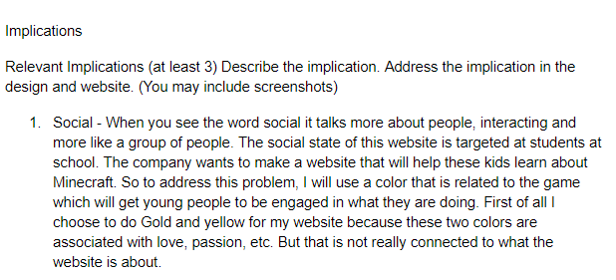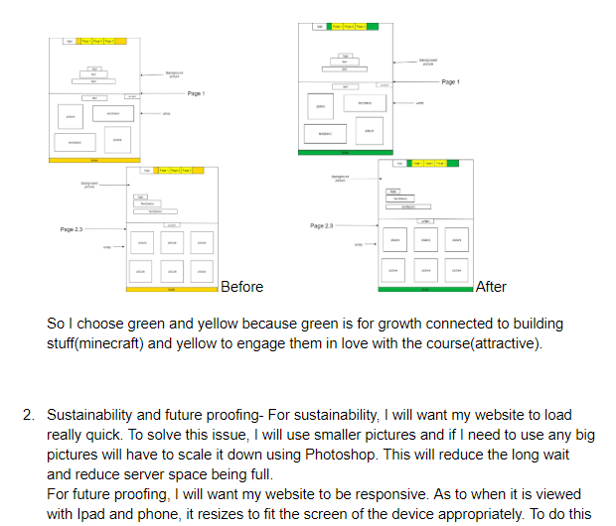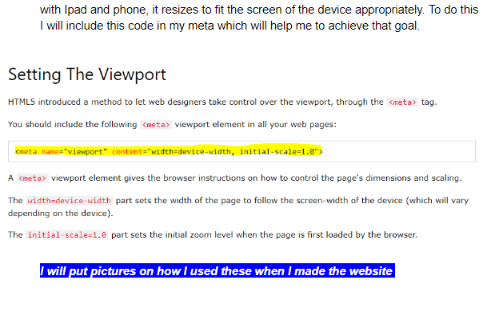

Day 5(13/04/2020)

Started doing the code. “Glitch” was not responding on my laptop so switched to “Playcode” and it also didn’t show what I was typing(probably didn’t do the code right). So I tried my best to get Notepad++ on my other computer.

I was able to do the code and everything; the setup mostly

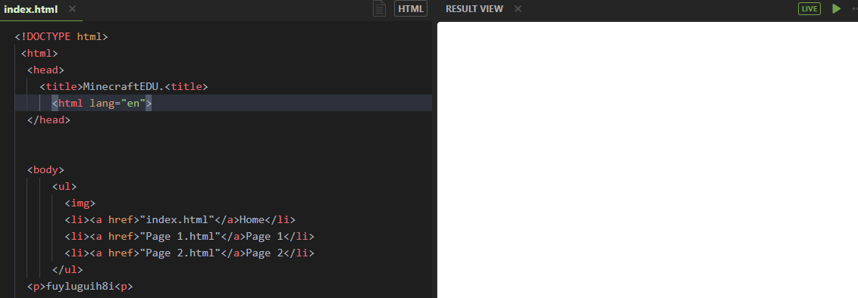

**Before:**  When I started with notepad++ today, I filled in the head section wrong, so it gave me a tab name looking like this. On the title tag was where the issue was from:

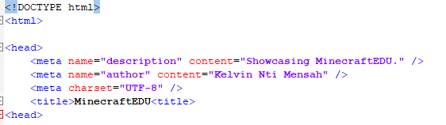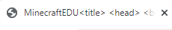

**After:** So I checked and realised I did a skim through my code, realising that I forgot to close the title tags. So I did that and it gave me “MinecraftEDU '' which needed to be projected out as I am doing it about MinecraftEDU and want the end users to see what they are opening as well. That made it more nicer.

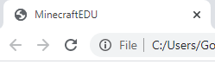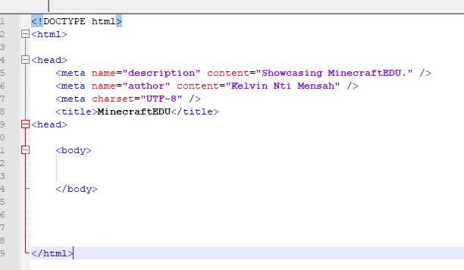

Day 6(14/04/2020) - Today I tried to create the navigation bar. I created all the tabs, which are: Logo, Home, Page 1 and Page 2. I saw that there was no need for the Logo to be styled or be linked so I took it out of my “a tag ” and “ul tag” and made it stand alone.

**Before:WIth Logo**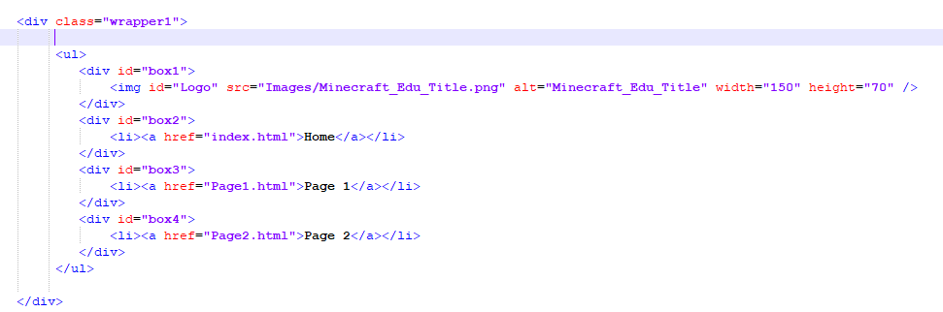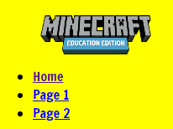

**After:Without Logo**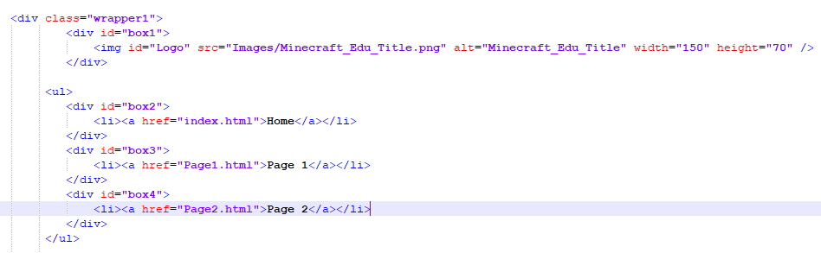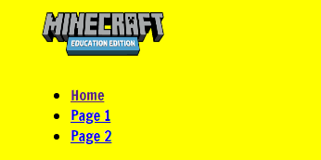

I had to link in my stylesheet into html so it had a color in my html. I linked it but didn’t write the name well so it didn’t show any effect on the website so I did a double and realised I spelt it wrong to what I named the folder.

**Before:Link** 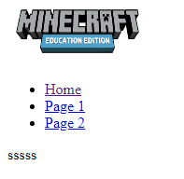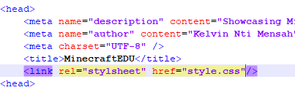

**After:Link Renewed**

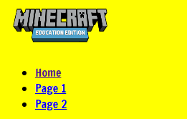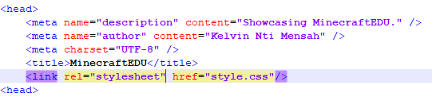



I had to put a font family into my css, so I just typed(my chosen font) “font-family=’Francois’, san-serif; It didn’t respond. I watched a video and it showed me how to put a font into css, by importing. So I used the @font-face and insected it. This had an effect on my website.

**Before:**

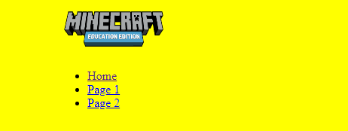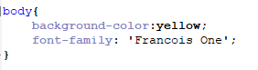

**After:**

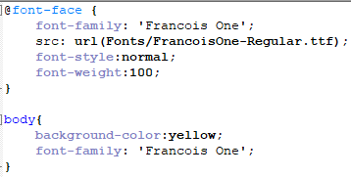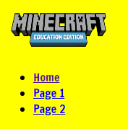

**Day 7: 15/04/2020**

On this day I made my background image with my navigation bar. I had a struggle in putting the picture in;I first put the picture in the body but realised it was wrong as whatever I write on the body will be on the image so created a container to fit it in.

**Before:**

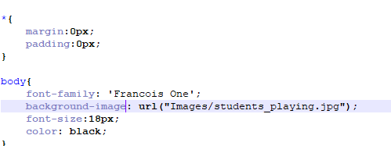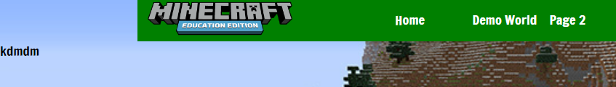

**After:**

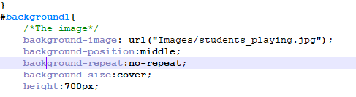

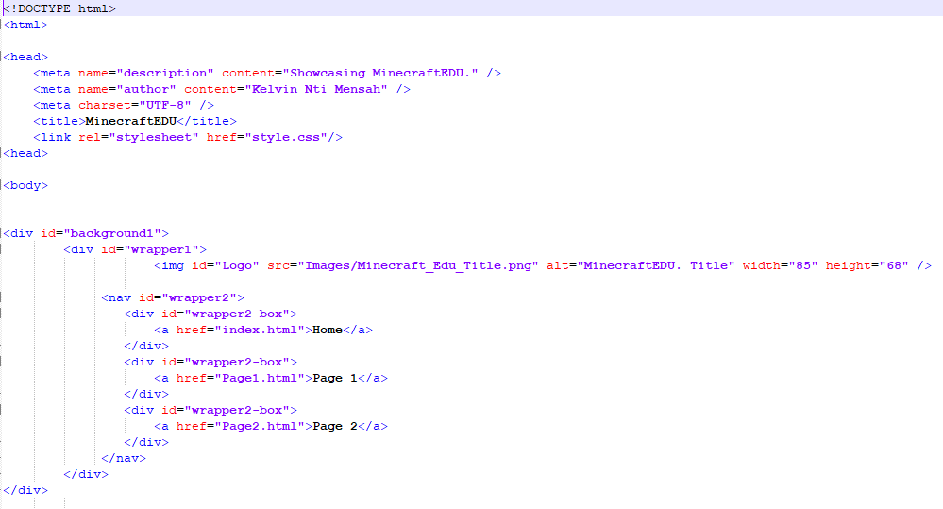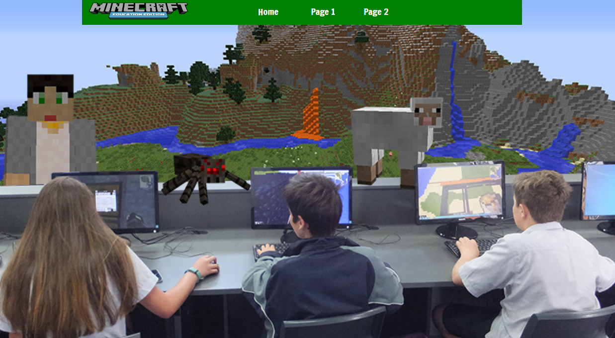

**Day 8: 16/04/2020**

On this day I created everything for the first page with the footer

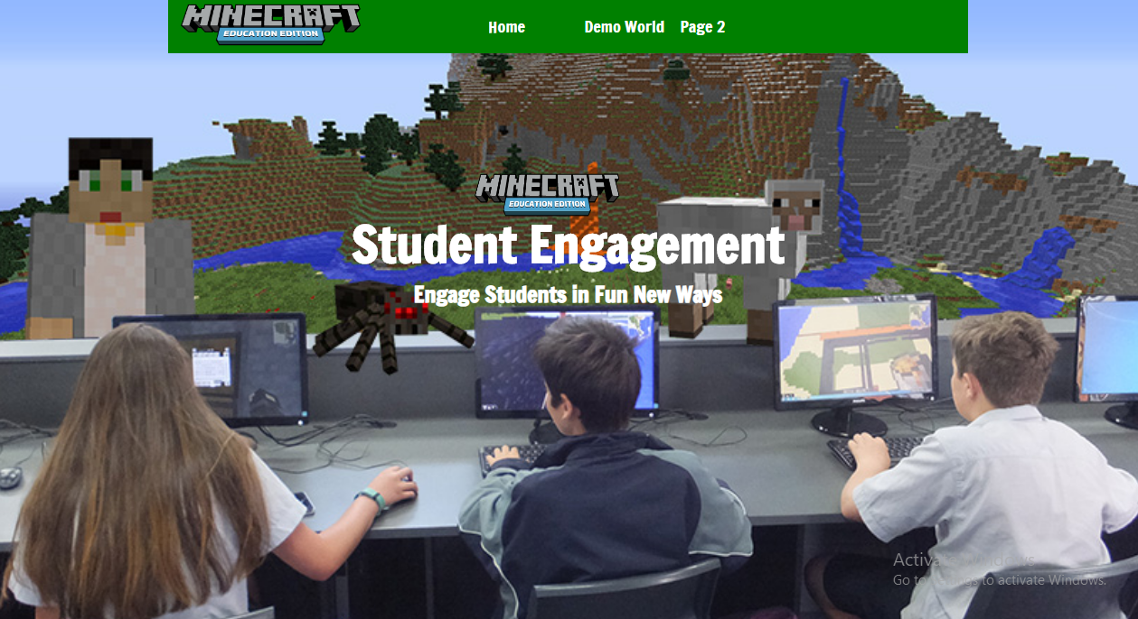

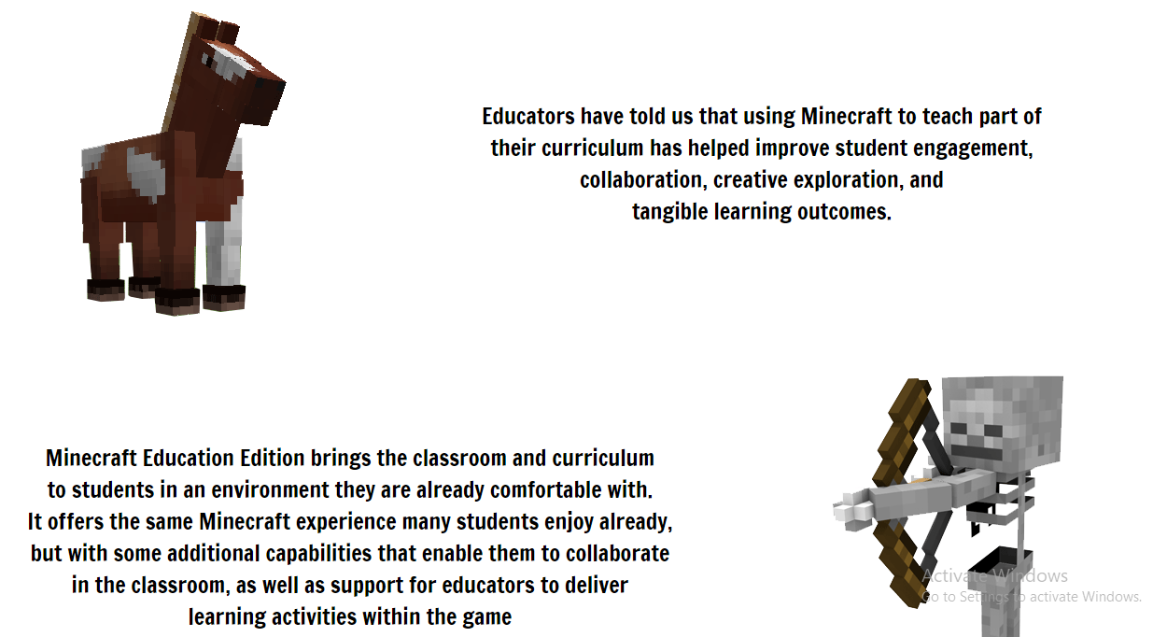



**Day 9:18/04/2020**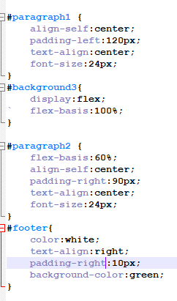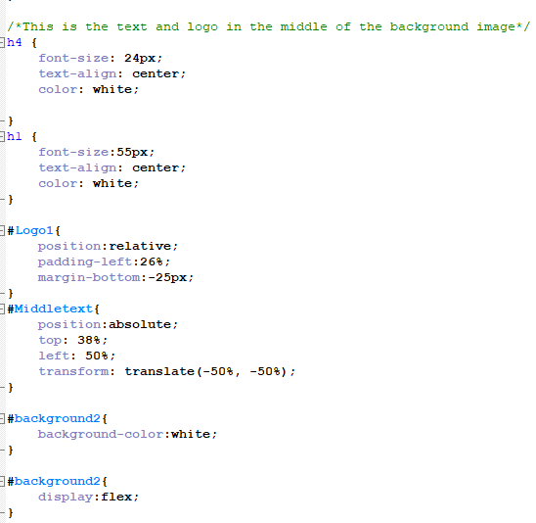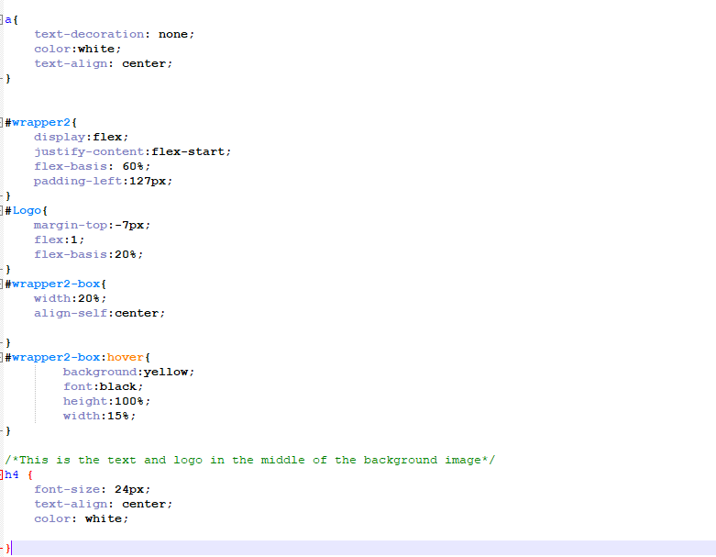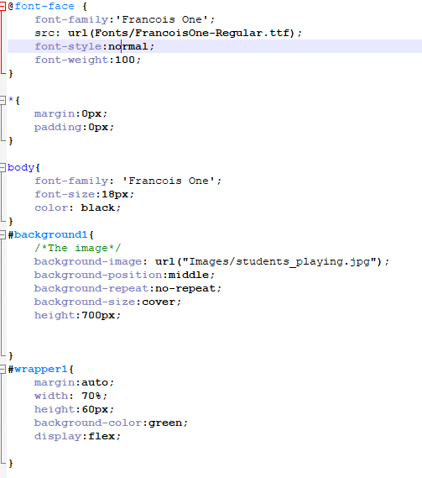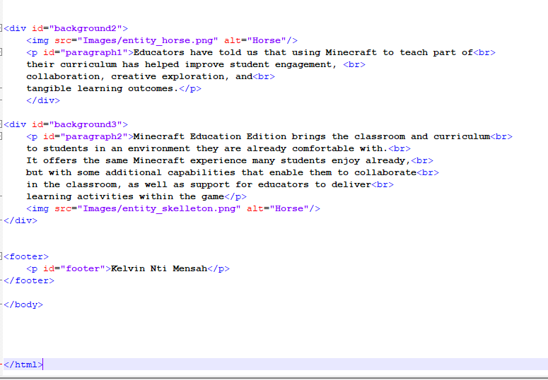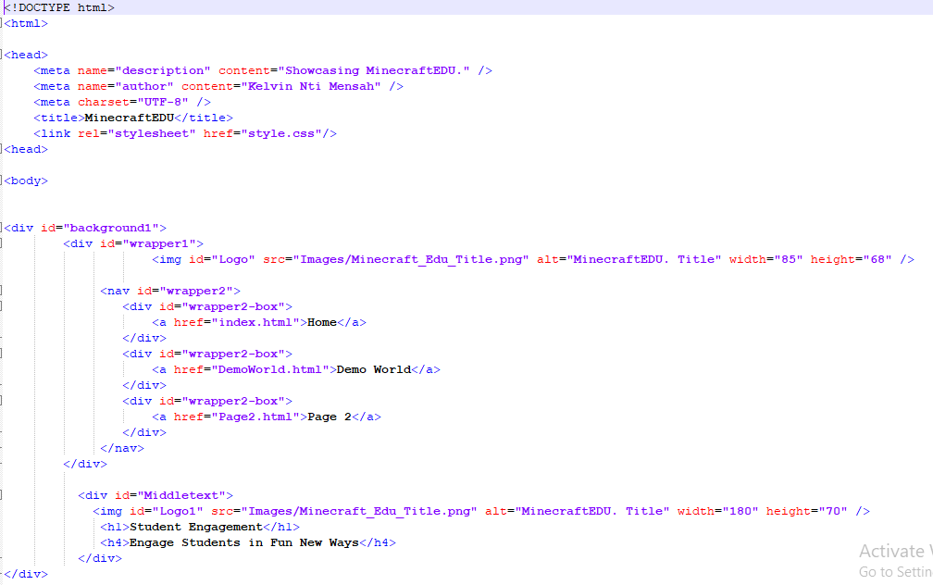

**Day 10:**

**I did validation today. When I uploaded it. This is what I saw.**

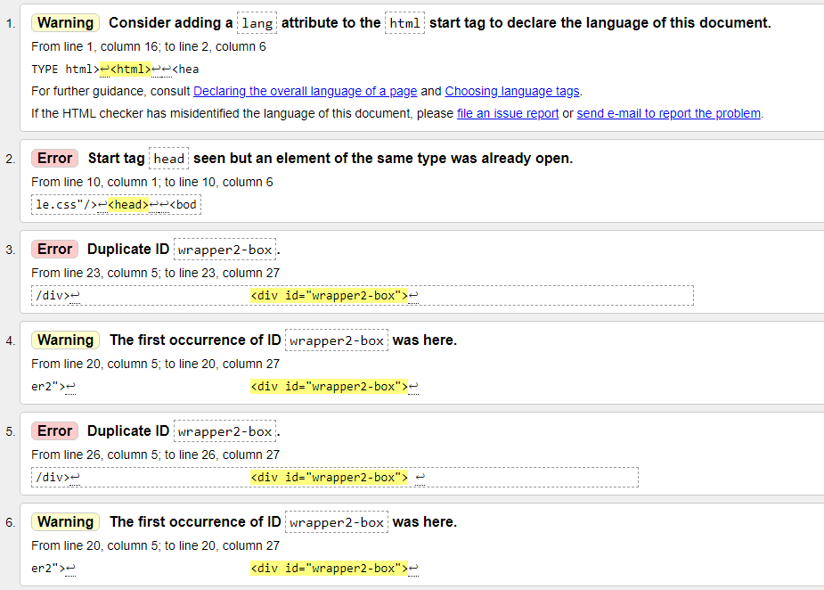

1)The thing that was wrong with the head tag was because there was no slash in it. So I put a slash in the head tag of the header. It didn’t really change the website in any way. But I believe that is the right way to do coding.

**Before:**

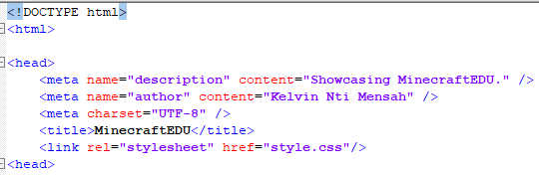

**After:**

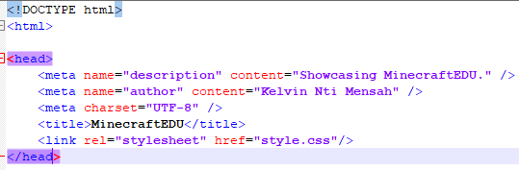

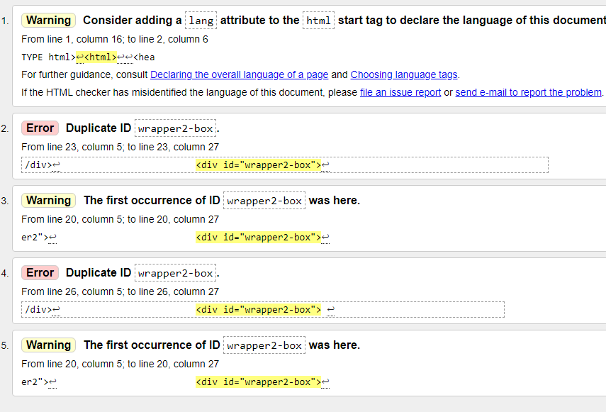

2)It says something about my “wrapper2-box”. When you look at my code work, you can see that I have repeated the “divs” around the links. I did that to help me style it. I just realised that I can do that styling with the “a tags” instead of repeating the “wrapper2-boxes” which is showing problems on the validator.

**Before:**



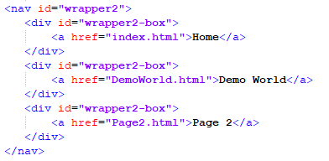

If you look at the css below, I have a weird editing for the “wrapper2-box” and “a tag” which is like the same thing.

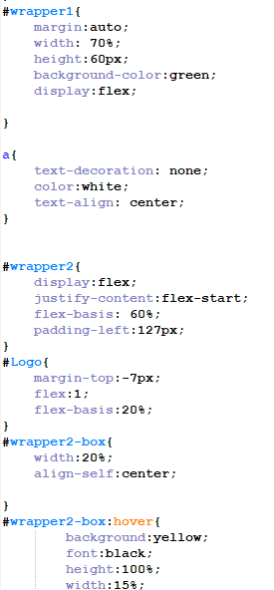

**After: I did it and it didn’t affect anything.**

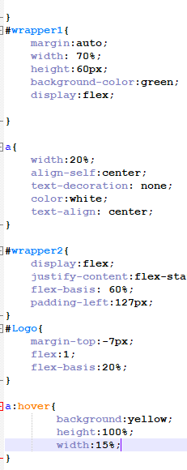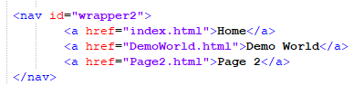

**After I was done, this was the response from the validator when I put the html in it again. No mistakes were shown. The one showing was something that is not really necessary.**

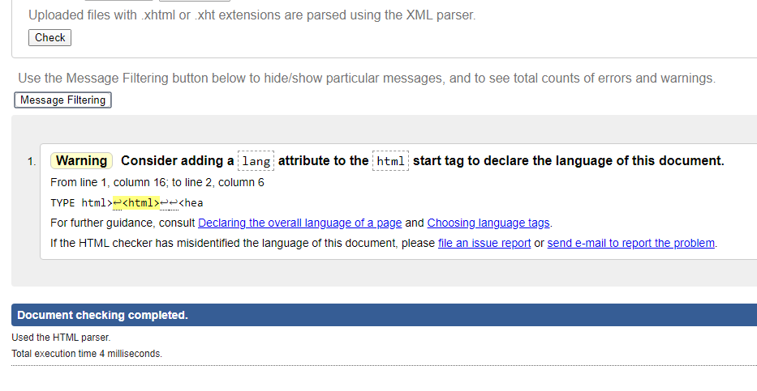

Day 11:19/04/2020

I was able to create the 2 pages which are “Demo World” and “Pricing” on this day. I didn’t really have any problems creating the Demo World because it was easy. What I found hard was on Page 3(Pricing) where the money pictures are located.

I wanted to put the contents in red in the middle. But I kept on struggling because everytime I code it to the left, it is always at the same place(they were in one div). After a number of tries, I decided to put the div called “PricePic” in all of the pictures and center and it worked.

**Before:**

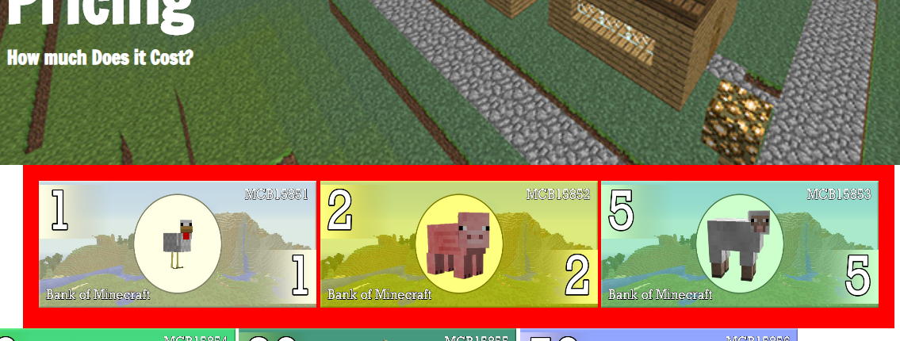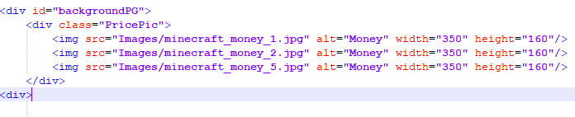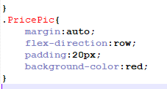

**After:**

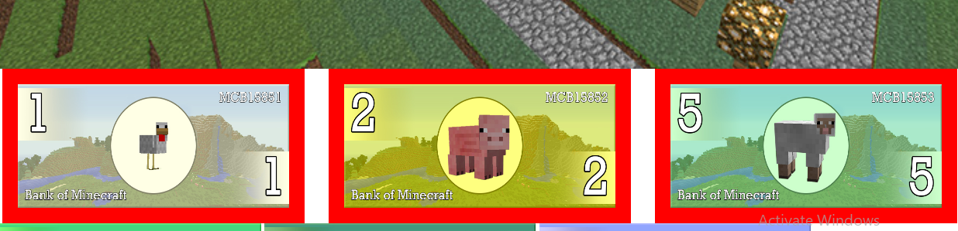

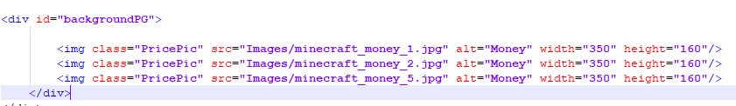



I also tried putting the same div around the picture.

I wanted another line of pictures with the same effect so I put the same divs in it and around it. This made everything line up

This is how it looks like with color around it:

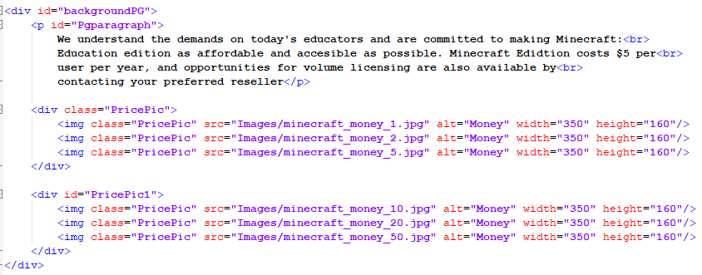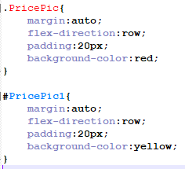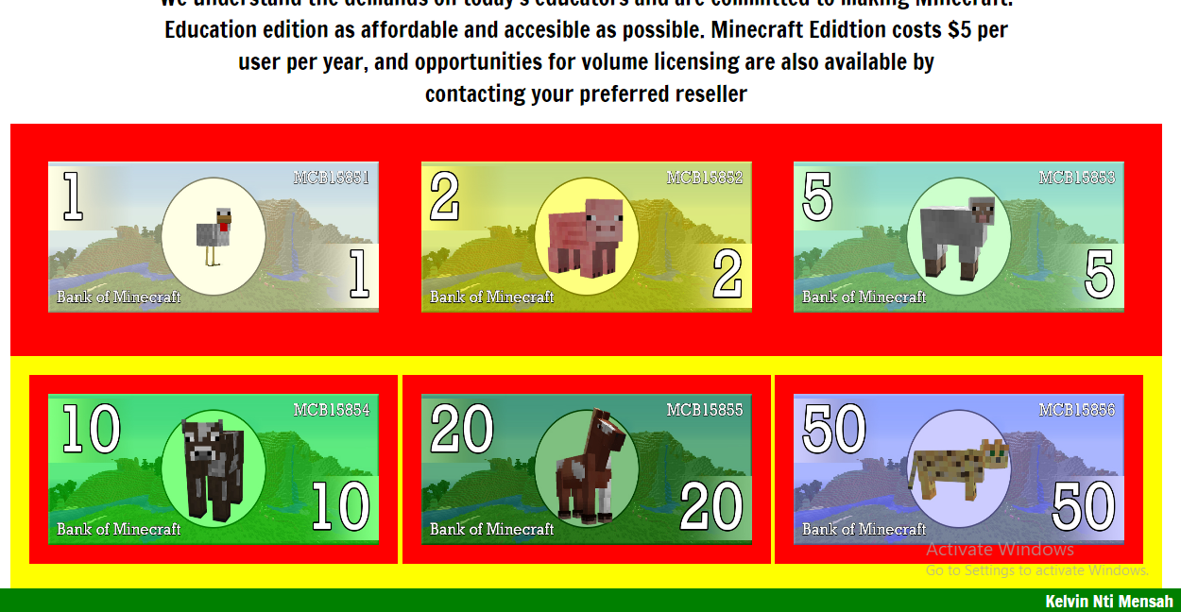

**I wrote a text on it as well.**

Day 12: 21/04/2020

On today I did validation on both my 2 pages to make sure everything is working(e.g link)

Demo World

It was the header again, same problem as the first page. I forgot to add a slash at the “head tag”. When I corrected that it was algs.

**Before:**

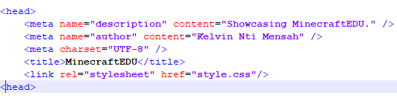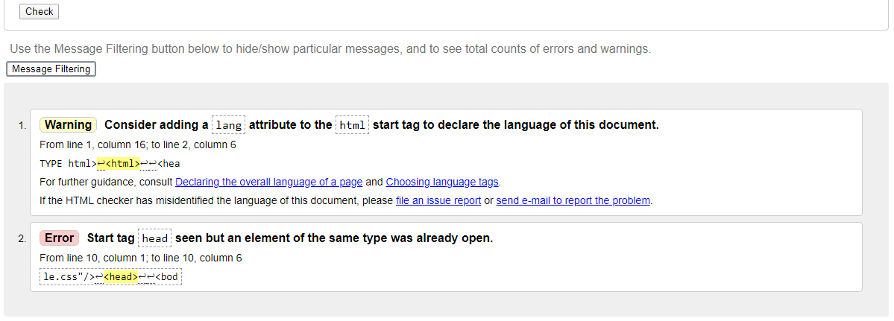

**After:**

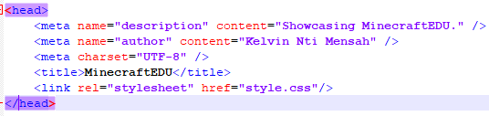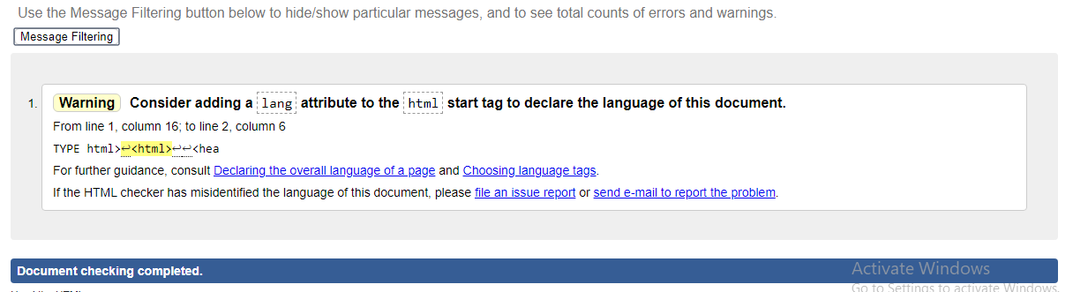

Pricing

This has no mistakes



Day 13: 22/04/2020

I added some comments to my css to help me know which page or what section I am looking at. I also put in the “meta viewport in all of my pages so they can be responsive and on other device screens. I had to change some “position” of my element to relative and another to absolute so they can be viewed nicely on any device.

**Comments in CSS:**

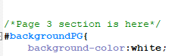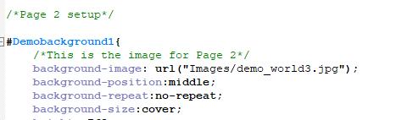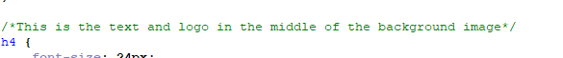

**“meta viewport”**

It views nicely. Not much to say. Here are some pictures

